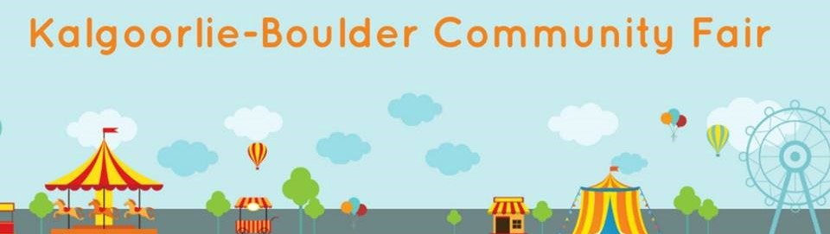

SCHOOLS EXPRESSION OF INTEREST

SCHOOL NAME: ______________________________ CONTACT PERSON: ________________________
EMAIL: _______________________________________ PHONE: ___________________________________

The 2021 Kalgoorlie-Boulder Community Fair has a range of activities that your school can be a part of. We know that schools are dynamic places and want to give you the opportunity to showcase the diverse skillsets of your students.

Yes, _____________________________________________________________School would like to participate in the 2020 Kalgoorlie-Boulder Community Fair. (please tick the activities where your school would like to be involved)

No, _________________________________________________________School is not able to participate this year.
- BANNER COMPETITION
Showcase your school’s take on our 2021 theme: All Together as One.

- FRUIT AND VEGETABLE COMPETITON
Does your school have a kitchen garden? Think about putting some produce into this years’ fruit and vegetable competition. See the Fruit and Vegetable Entry Form on our website for categories.

- RECYCLED ART COMPETITON
Get the students to use all of that creative energy to develop art made from recycled materials. A great lesson on the impact of waste on the environment!

- LEGO COMPETITION
With the Lego Masters TV getting kids once again enthusiastic about Lego why not get them involved in our Lego competition.

- ROBOTIC LEGO COMPETITION
This tests the skills of the technological minded with team pitted against team in a robotic Lego task. See the Robotics Lego Entry Form for more details.

- ENTERTAINMENT ON STAGE AREAS
Do you have a choir, band, dance or performance group at your school that would relish the opportunity of a public performance? Timeslots of 20 mins are available from 12-7pm Friday and 10am to 7pm on Saturday.

- HANDICRAFTS
Knitting, quilting, clothing design, crochet and more.

- COOKING COMPETITION
Categories include cake decorating, biscuits, slices, jams and preserves and more.

All competition entry forms are available at https://www.kbfair.org.au/

Provision of Shade
We are always in need of shade at the fair. Would your school be happy to lend us some sporting tents for the weekend of the fair?
Yes Number: _____________
No

Please direct any questions or queries to Schools Liaison, Kylie McLerie 0418905633

Please scan and return to info@kbfair.org.au

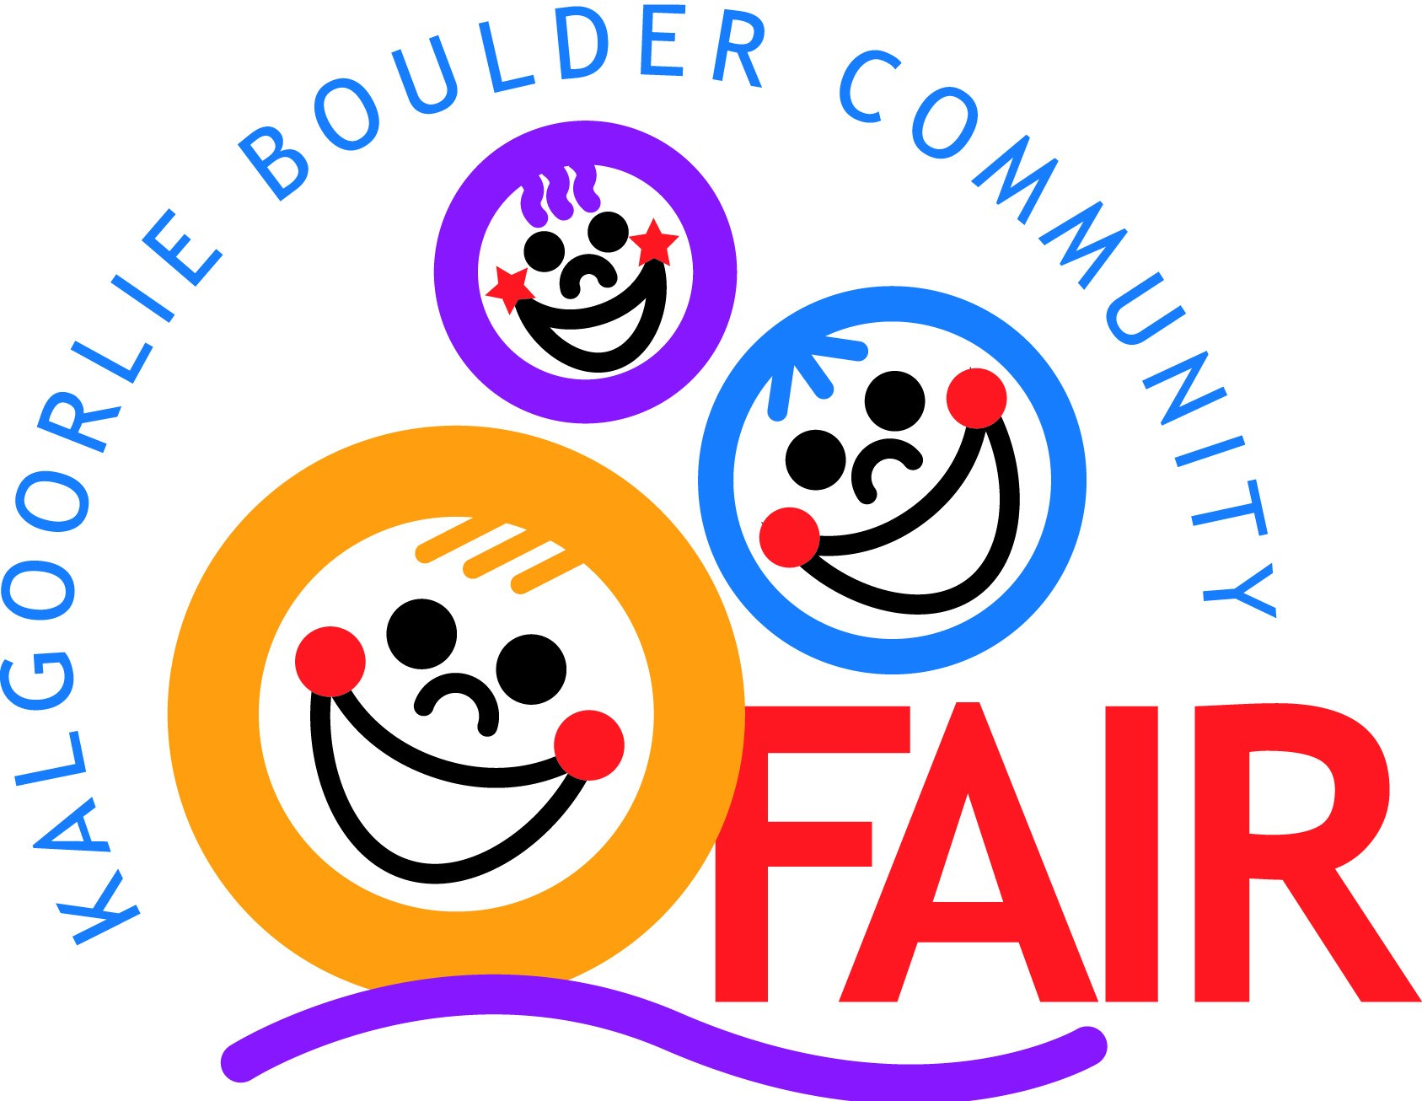
Kalgoorlie Boulder Community Fair Society Inc
PO Box 399 Kalgoorlie WA 6430
Telephone: (08) 9021 4995
Facsimile:(08) 9021 1773
E-Mail Address: info@kbfair.org.au Website: www.kbfair.org.au
Or follow us on Facebook

