2021 Kalgoorlie-Boulder
Community Fair

Robotics Competition

Guidelines and Application Form

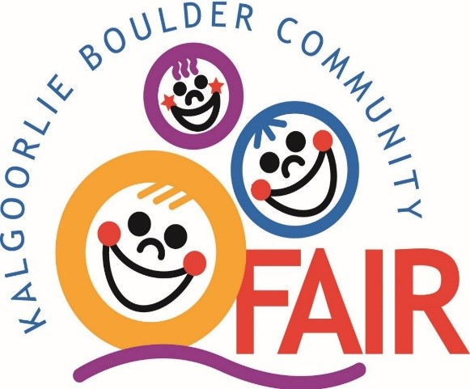

Robotics COMPETITION

Can you create and program your robotic vehicle to do the complete the challenge and finish the task?

Get your team together and be part of the Kalgoorlie-Boulder Community Fair Lego robotics competition.

Our 2021 competition will be held at the fair at 1pm Saturday March 27.

Classes

There is only one class for this event.
Teams of up to five members (minimum of 3) will compete to finish the task.
Team members are to be school aged.

Entry Conditions

- Entry forms available from the Kalgoorlie-Boulder Fair Society Facebook page and www.kbfair.org.au
- Entry forms can be posted to Kalgoorlie-Boulder Fair Society, PO Box 399, KALGOORLIE WA 6433, emailed to peta.osborne@gmail.com or dropped off to the KBCFS office, Cruickshanks Sports Arena
- Entry forms must be submitted by Wednesday 17 March. No late entries accepted.
- Your team must be prepared to attend the pre training on Saturday 20 March 1pm at the Museum of the Goldfields.
- Each team will need at least 2 Bluetooth enabled mobile devices with the WeDo 2.0 app installed. Free App available through Playstore or Appstore

Prizes
TBD

Entry Fee
Entry fee is $10 per team

For further information please contact Peta Osborne on peta.osborne@gmail.com or 0418 951 472 or visit the fair website on https://www.kbfair.org.au/ or message us on Facebook

2021 Kalgoorlie-Boulder Community Fair
Robotics Competition Entry Form

Team Name:

Postal Address:

Main Phone Number:

Team Members
Name | Parent/Guardian Name and phone number | Signature
Entry Fee Paid:
Pre-Competition Training:
Saturday 20 March 1pm at the Museum of the Goldfields
Competition Day:
Saturday 27 March 1pm at the Kalgoorlie-Boulder Fair
PLEASE NOTE:
Each team will need at least 2 Bluetooth enabled mobile devices with the WeDo 2.0 app installed. Free App available through Playstore or Appstore
For any further information required, please call Peta Osborne on 0418 951 472 or visit us https://www.kbfair.org.au or message us through Facebook

